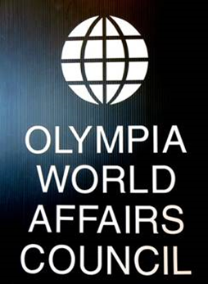
OWAC invites you and your guests to our

Annual Spring Reception

Thursday May 17, 2018

6 - 8 p.m.

Indian Summer Golf & Country Club
5900 Troon Lane SE, Olympia, WA

Enjoy an evening with people interested in world affairs
Presentation of OWAC’s sixth annual Global Connect Award to:

Olympia Chapter, Dining for Women

Dr. Marie Johantgen, Founder & Leader

Hors d’oeuvres buffet, coffee and tea included
Wine, beer, liquor & soft drinks may be purchased at cash bar

___________________________________________________
Please reply by May 4th

$35 per member or $45 per non-member includes hors d’oeuvres, coffee and tea; cash bar for other drinks

Seating is limited, so please send in your RSVP as soon as possible

Name (s) _____________________________________________ Phone _________

Make checks payable to: Olympia World Affairs Council
PMB 712, 2103 Harrison Ave. NW Suite 2
Olympia, WA 98502-2607

