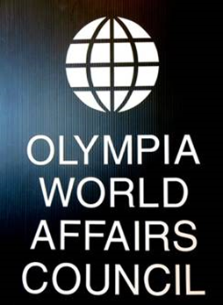
Annual Spring Reception

Thursday May 16, 2019

6:00 – 8:00 P.M.

Indian Summer Golf & Country Club
5900 Troon Lane SE, Olympia, WA

Presentation of OWAC’s seventh annual Global Connect Award to
The Alaffia Foundation
Rose Hyde & Olowo-n'djo Tchala, co-founders

The Alaffia Foundation (TAF) is a 501(c)(3) organization based in Olympia whose mission is to empower African communities through the advancement of fair trade, education, sustainable living and gender equality. www.alaffia.com

Hors d’oeuvres buffet, coffee and tea
No-host cash bar
___________________________________________________
Please reply by May 6th

$35 per OWAC member, $45 per non-member. The member price applies to OWAC members of this program year, 2018-2019, and for the next program year, 2019-2020 (membership form is attached). Please remit by check to OWAC.

Name(s) __________________________________________ Phone ____________

Address _____________________________________________________________

Make check payable to: Olympia World Affairs Council
PMB 712, 2103 Harrison Ave. NW Suite 2
Olympia, WA 98502-2607

